|  |  |
| --- | --- |
| CRM  (customer relation management) | ERP  (enterprise resource planning) |
| Start with sales department management | Start with financial management |
| Mange customer interactions with systems | Manage business resources |
| Deal with customer data only | Shared data base to all parts of business |
| Cannot handle transactions with data, it read only data to analysis it | Handle interactions with data as it mange all business resources |
| Doesn’t have ERP systems | Sometimes have CRM systems internal |

Assigment2:

1] Case study1: A personal insulin pump

product type: Customized products

application type: Embedded control systems

model: v model

----------------------------------------------------------------------

2] Case study2: Mentcare: A mental health support system

product type: Customized products

application type: Stand-alone applications

model: waterfall

---------------------------------------------------------------------

3] Case study3: weather

product type: Customized products

application type: Data collection systems, Embedded control systems

model: waterfall

Assignment3:

1] spiral mode

-methodology: it is a combination of plan driver development specifically (water fall model and incremental models)

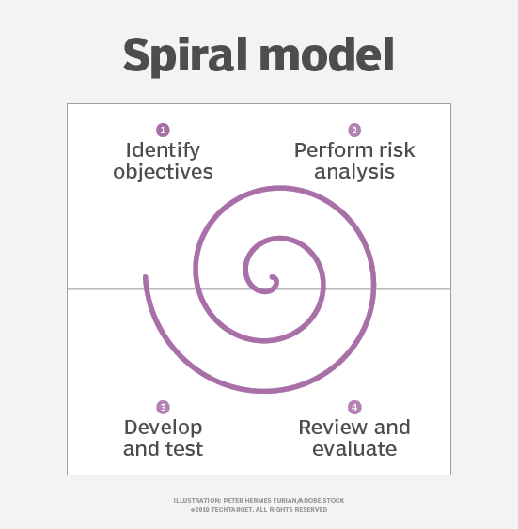

In spiral mode, each loop represents a phase in development process where consist of basic 4 parts

1-analysis (gathering requirements, solutions)

2-planning and design (risks, porotype)

3-development (code, test)

4-deployment (review, support, feedback)

And so on till final deployment.

-when we use it:

1-the large projects and also projects that already started

2-customer need to see frequently the project

3-high risk projects

4-clients are not clear about requirements

5-frequent changes

|  |  |
| --- | --- |
| advantage | disadvantage |
| Flexibility in requirements  (changes or additional requirements can be added later) | Cost (it consider an expensive method so it is not suitable for small projects) |
| Fast deployment | Can take very long time ( the reputation of phases till final deployment is unknown) |
| Customers can see the project features before final deployment so it is garneted the projects fits exactly his requirements |  |
| Well risk handling (at each phase risk is calc and handled) |  |

2]V mode (Verification and validation)

-methodology: it is a plan driver development

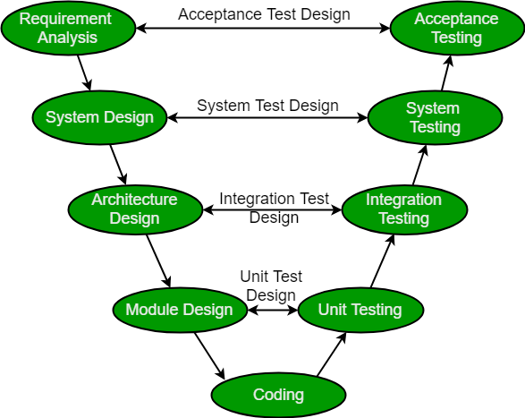

Pic copyright Geeks for Geeks

Ii is the same phases as waterfall model but instead of waiting till development finish to start test phase, at each phase there is a test created to test. After the product is finished development the tests test the product for the requirements of each phase till reach to acceptance test.

In V model tests is run

-when we use it:

1-the requirements are clear and defined

2-high reliability projects

3-small to medium projects with no frequent change

|  |  |
| --- | --- |
| advantage | disadvantage |
| Simple and easy to understand and use | Not suitable for complex projects |
| Reliable (as it well tested and can make error free , high quality projects ) | High risk  (requirements can be changed during process) |
| Fixed time and well management | Can be used with concurrent events |